CS 3305-01 Web Programming 2

Instructor: Professor Jim Casale

Name: Anonymos

Programming Assignment Unit 7

For this assignment, I downloaded and installed an extension called "Latest News Enhanced."

The main features of Latest News Enhanced are as follows:

1. Advanced Filtering Options: It allows articles to be filtered by category, author, or date range, giving precise control over the content displayed.
2. Display Customization: The module offers various layout options, allowing you to show or hide article details such as the author, date, and introduction text.
3. Support for Multiple Templates: It supports multiple templates, making it easier to match the style of the news articles to the design of the site.
4. Performance Improvements: The module includes performance enhancements to optimize the loading time of news articles, especially when managing a large amount of content.
5. Responsive Design: It is fully responsive, ensuring that the news display adapts seamlessly to different screen sizes and devices.

Below is a screenshot of the module list screen after executing the download.

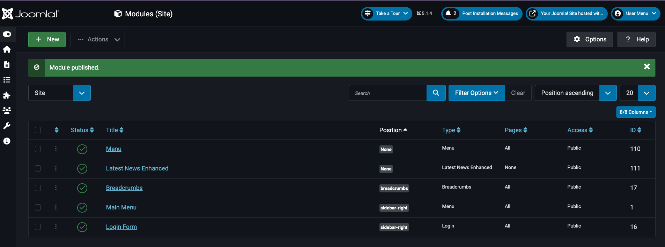

Figure 1: Screenshot showing that the extension has been installed.

Word Count: 159

References

1. CloudAccess.net. (n.d.). *Cloud control panel (CCP).* Retrieved from <https://ccp.cloudaccess.net/>
2. Simplify Your Web. (n.d.). *Latest News Enhanced.* Retrieved from https://simplifyyourweb.com/free-products/latest-news-enhanced